V

r"/

* 23
* 21 SS. tiosi

ci-/

NA *H* A S.ETH

- 144392_0005

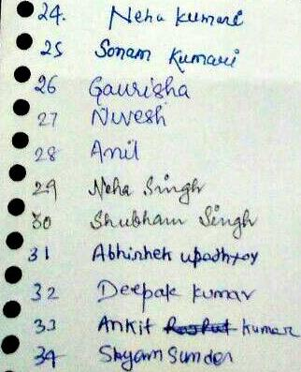

* 04.
* .2.c.
* 27
* Qt
* 2,1
* &a

•

3 1

.3a

33

•

Cl

*J. /V 71 n 4 rot* 14-802?? ICJ*

* *oz. suvrevt,),,,.0 s; e0( 1s-03010 3p0*3

•

ww,no,„,0,,,,,1 To *0* 5 a 0 0 2 2.*e)*

* *A*

*nmari* 0;7,4 *risosoucivgj*

*•*

irnotrvwt

* eis°30/2022'
* knitilIctu N(311 - isog013031
* /1(1,11,0 11300a7t;' - !Sago twzo
* AmbhaA) KmitottA) — S030 co *4- o*
* 31A LL

*otsLuna tiog i 0* 05 3

* Pradr ttulAAA- libOgulb0

• )0

•

* 1***t***
* 1 2.
* *13.*

*.14.*

iCtAketskan *Jetheer, — ltfoiotootts V nctsctick* vas-hatv, — 14 act oi ot3433

PficAtrilittL : /1::009c4: W31°032-

*at ago--/) 2.041-1*

*sid citiK 4.09o31* o3

mac

* - *SmORKI cMISWAL " I 4* ***61‘01 0 1 i***

***q090 0/016***

* ***Ant SALHO***

- 1509010077

* 8. Vioximojeck
* 19- PRAsHAKs-r quJ6L - isogoto 0-7 *6*
* *.2-0 NezezAJ sH mo —* 1501ot° tZ7





* 21 Wtabatyl -Lk),

I zi z9 20004/

|  |
| --- |
| - 1.5090100(  - I 5 0g0 Lou?  - *1S0900202*  - tttego3*tot7*  *t keo cio r6.047 itto 10( tiro 2t,*  *tiloz\oi*  *tioio lot* I r |

is-ose )0008

11)0901090 L

Iso9e10035

*C S E - secfrj)*

I co °Jo flo 64